**Create a Quiz Application.**

1. Generate UI on the Basis of JSON give below
2. Validate each steps
3. Validate Questions
4. Display result page.  
     
   **Estimate time** : 6 hours

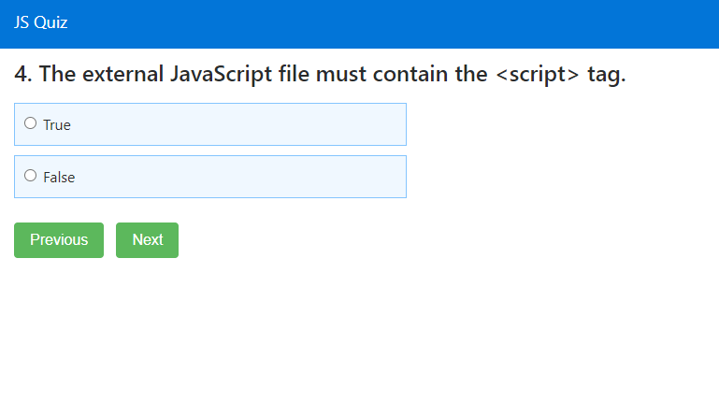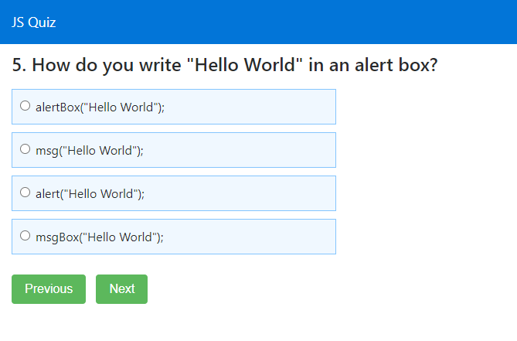

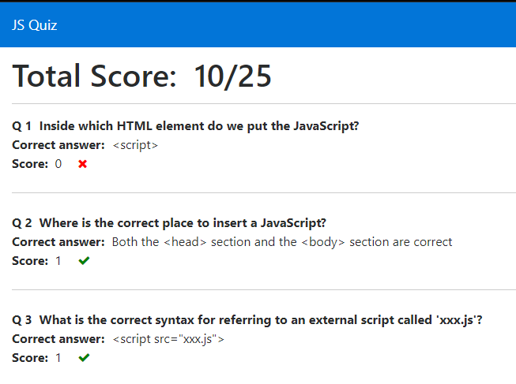

JSON

var quiz = { "JS" : [

{

"id" : 1,

"question" : "Inside which HTML element do we put the JavaScript?",

"options" : [

{"a": "&lt;script&gt;",

"b":"&lt;javascript&gt;",

"c":"&lt;scripting&gt;",

"d":"&lt;js&gt;"}

],

"answer":"&lt;script&gt;",

"score":0,

"status": ""

},

{

"id" : 2,

"question" : "Where is the correct place to insert a JavaScript?",

"options" : [

{"a": "The &lt;head&gt; section",

"b":"The &lt;body&gt; section",

"c":"Both the &lt;head&gt; section and the &lt;body&gt; section are correct"}

],

"answer":"Both the &lt;head&gt; section and the &lt;body&gt; section are correct",

"score":0,

"status": ""

},

{

"id" : 3,

"question" : "What is the correct syntax for referring to an external script called 'xxx.js'?",

"options" : [

{"a": "&ltscript href=&quot;xxx.js&quot;>",

"b":"&lt;script name=&quot;xxx.js&quot;&gt;",

"c":"&lt;script src=&quot;xxx.js&quot;&gt;"}

],

"answer":"&lt;script src=&quot;xxx.js&quot;&gt;",

"score":0,

"status": ""

},

{

"id" : 4,

"question" : "The external JavaScript file must contain the &lt;script&gt; tag.",

"options" : [

{"a": "True",

"b":"False"

}

],

"answer":"False",

"score":0,

"status": ""

},

{

"id" : 5,

"question" : "How do you write &quot;Hello World&quot; in an alert box?",

"options" : [

{"a": "alertBox(&quot;Hello World&quot;);",

"b":"msg(&quot;Hello World&quot;);",

"c":"alert(&quot;Hello World&quot;);",

"d":"msgBox(&quot;Hello World&quot;);",

}

],

"answer":"alert(&quot;Hello World&quot;);",

"score":0,

"status": ""

},

{

"id" : 6,

"question" : "How do you create a function in JavaScript?",

"options" : [

{"a": "function myFunction()",

"b":"function:myFunction()",

"c":"function = myFunction()",

}

],

"answer":"function myFunction()",

"score":0,

"status": ""

},

{

"id" : 7,

"question" : "How do you call a function named &quot;myFunction&quot;?",

"options" : [

{"a": "call function myFunction()",

"b":"call myFunction()",

"c":"myFunction()",

}

],

"answer":"myFunction()",

"score":0,

"status": ""

},

{

"id" : 8,

"question" : "How to write an IF statement in JavaScript?",

"options" : [

{"a": "if i = 5 then",

"b":"if i == 5 then",

"c":"if (i == 5)",

"d":" if i = 5",

}

],

"answer":"if (i == 5)",

"score":0,

"status": ""

},

{

"id" : 9,

"question" : "Which of the following is a disadvantage of using JavaScript?",

"options" : [

{"a": "Client-side JavaScript does not allow the reading or writing of files.",

"b":"JavaScript can not be used for Networking applications because there is no such support available.",

"c":"JavaScript doesn't have any multithreading or multiprocess capabilities.",

"d":"All of the above."

}

],

"answer":"All of the above.",

"score":0,

"status": ""

},

{

"id" : 10,

"question" : "How to write an IF statement for executing some code if &quot;i&quot; is NOT equal to 5?",

"options" : [

{"a": "if (i <> 5)",

"b":"if i <> 5",

"c":"if (i != 5)",

"d":"if i =! 5 then",

}

],

"answer":"if (i != 5)",

"score":0,

"status": ""

},

{

"id" : 11,

"question" : "How does a WHILE loop start?",

"options" : [

{"a": "while i = 1 to 10",

"b":"while (i &lt;= 10; i++)",

"c":"while (i &lt;= 10)"

}

],

"answer":"while (i &lt;= 10)",

"score":0,

"status": ""

},

{

"id" : 12,

"question" : "How does a FOR loop start?",

"options" : [

{"a": "for (i = 0; i &lt;= 5)",

"b":"for (i = 0; i &lt;= 5; i++)",

"c":"for i = 1 to 5",

"d":"for (i &lt;= 5; i++)"

}

],

"answer":"for (i = 0; i &lt;= 5; i++)",

"score":0,

"status": ""

},

{

"id" : 13,

"question" : "How can you add a comment in a JavaScript?",

"options" : [

{"a": "//This is a comment",

"b":"&sbquo;This is a comment",

"c":"&lt;!--This is a comment--&gt;"

}

],

"answer":"//This is a comment",

"score":0,

"status": ""

},

{

"id" : 14,

"question" : "How to insert a comment that has more than one line?",

"options" : [

{"a": "/*This comment has more than one line*/",

"b":"//This comment has more than one line//",

"c":"&lt;!--This comment has more than one line--&gt;"

}

],

"answer":"/*This comment has more than one line*/",

"score":0,

"status": ""

},

{

"id" : 15,

"question" : "What is the correct way to write a JavaScript array?",

"options" : [

{"a": "var colors = (1:&quot;red&quot;, 2:&quot;green&quot;, 3:&quot;blue&quot;)",

"b":"var colors = [&quot;red&quot;, &quot;green&quot;, &quot;blue&quot;]",

"c":"var colors = 1 = (&quot;red&quot;), 2 = (&quot;green&quot;), 3 = (&quot;blue&quot;)",

"d":"var colors = &quot;red&quot;, &quot;green&quot;, &quot;blue&quot;"

}

],

"answer":"var colors = [&quot;red&quot;, &quot;green&quot;, &quot;blue&quot;]",

"score":0,

"status": ""

},

{

"id" : 16,

"question" : "How do you round the number 7.25, to the nearest integer?",

"options" : [

{"a": "rnd(7.25)",

"b":"Math.round(7.25)",

"c":"Math.rnd(7.25)",

"d":"round(7.25)"

}

],

"answer":"Math.round(7.25)",

"score":0,

"status": ""

},

{

"id" : 17,

"question" : "How do you find the number with the highest value of x and y?",

"options" : [

{"a": "Math.max(x, y)",

"b":"Math.ceil(x, y)",

"c":"top(x, y)",

"d":"ceil(x, y)"

}

],

"answer":"Math.max(x, y)",

"score":0,

"status": ""

},

{

"id" : 18,

"question" : "What is the correct JavaScript syntax for opening a new window called &quot;w2&quot;?",

"options" : [

{"a": "w2 = window.new(&quot;http://www.w3schools.com&quot;);",

"b":"w2 = window.open(&quot;http://www.w3schools.com&quot;);"

}

],

"answer":"w2 = window.open(&quot;http://www.w3schools.com&quot;);",

"score":0,

"status": ""

},

{

"id" : 19,

"question" : "JavaScript is the same as Java.",

"options" : [

{"a": "true",

"b":"false"

}

],

"answer":"false",

"score":0,

"status": ""

},

{

"id" : 20,

"question" : "How can you detect the client&rsquo;s browser name?",

"options" : [

{"a": "navigator.appName",

"b":"browser.name",

"c":"client.navName"

}

],

"answer":"navigator.appName",

"score":0,

"status": ""

},

{

"id" : 21,

"question" : "Which event occurs when the user clicks on an HTML element?",

"options" : [

{"a": "onchange",

"b":"onclick",

"c":"onmouseclick",

"d":"onmouseover"

}

],

"answer":"onclick",

"score":0,

"status": ""

},

{

"id" : 22,

"question" : "How do you declare a JavaScript variable?",

"options" : [

{"a": "var carName;",

"b":"variable carName;",

"c":"v carName;"

}

],

"answer":"var carName;",

"score":0,

"status": ""

},

{

"id" : 23,

"question" : "Which operator is used to assign a value to a variable?",

"options" : [

{"a": "*",

"b":"-",

"c":"=",

"d":"x"

}

],

"answer":"=",

"score":0,

"status": ""

},

{

"id" : 24,

"question" : "What will the following code return: Boolean(10 &gt; 9)",

"options" : [

{"a": "NaN",

"b":"false",

"c":"true"

}

],

"answer":"true",

"score":0,

"status": ""

},

{

"id" : 25,

"question" : "Is JavaScript case-sensitive?",

"options" : [

{"a": "No",

"b":"Yes"

}

],

"answer":"Yes",

"score":0,

"status": ""

}

]

}